**Phonegap and MySQL database Example**

1. **Setup and programming for server side with database.**

* Installed mySQL server and MySQL workbench.
* Open mySQL workbench, create a new database and a table as following:

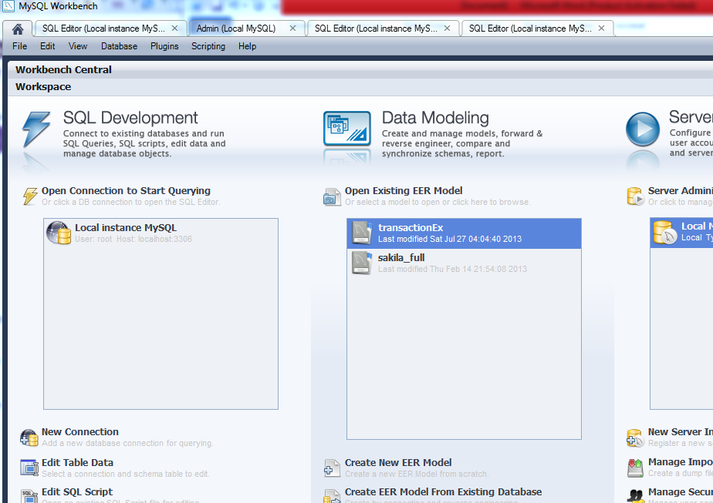

Click on “ Local Instance MYSQL”

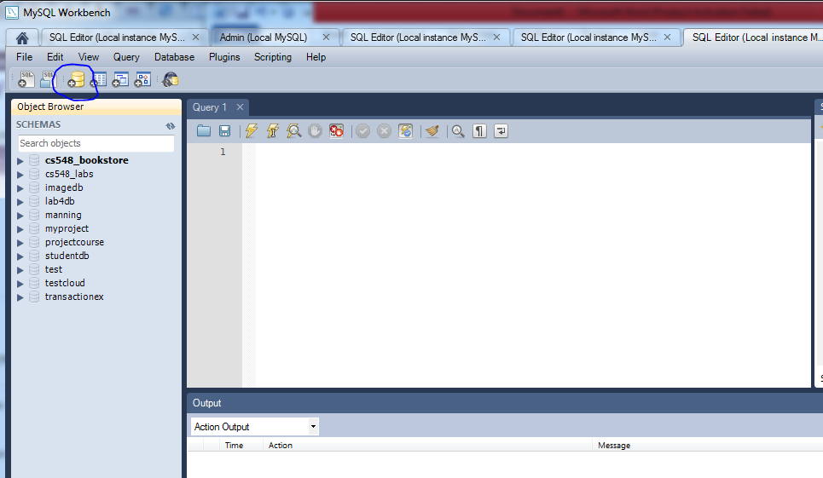

Click on create database icon to create a new database.

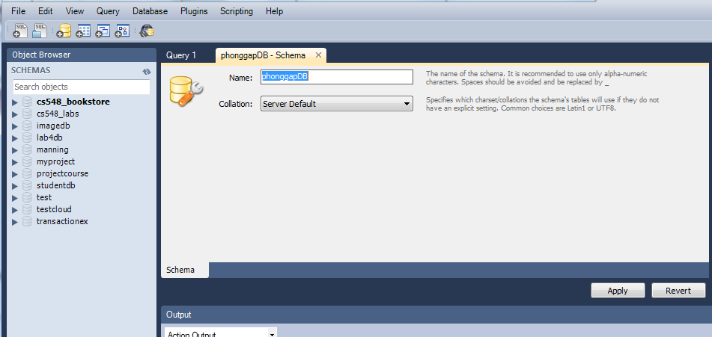

For example: type the name of database as “phonegapDB”

Click Apply.

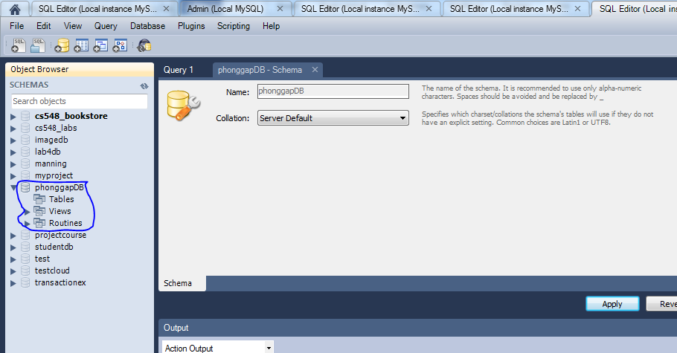

Right click on Tables of database phonggapDB to create a new table.

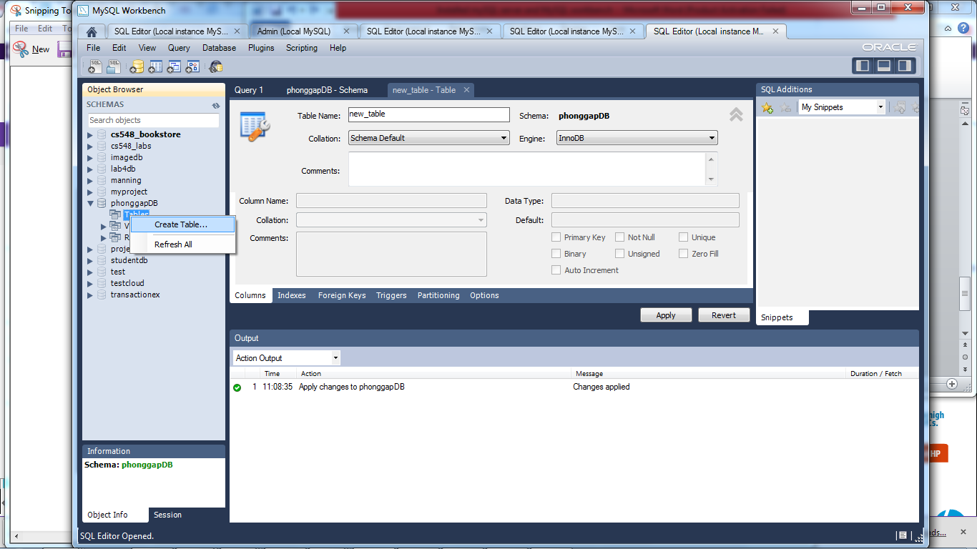

For example, enter table name as Users to create Users table.

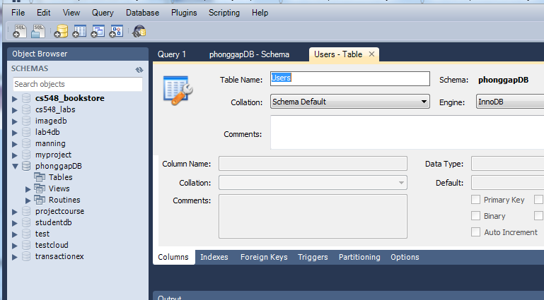

Click the icon “up” to go to the screen to add some columns.

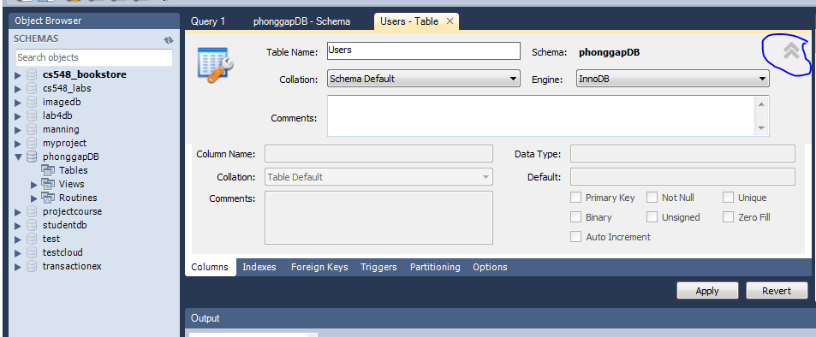

Add “id” column as following

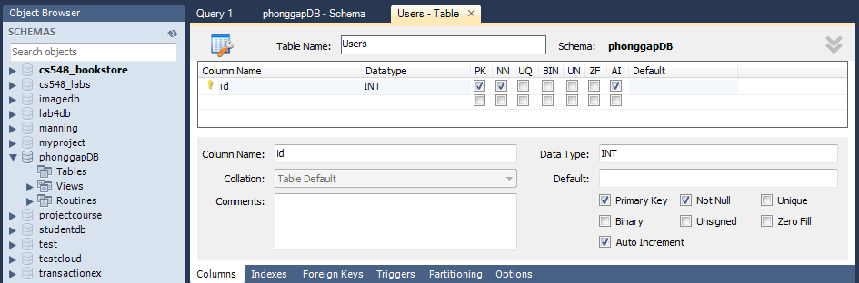

Add “firstName” column as following:

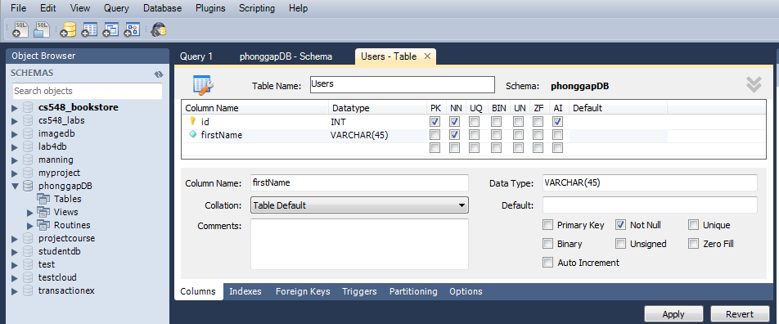

Add “lastName” column as following:

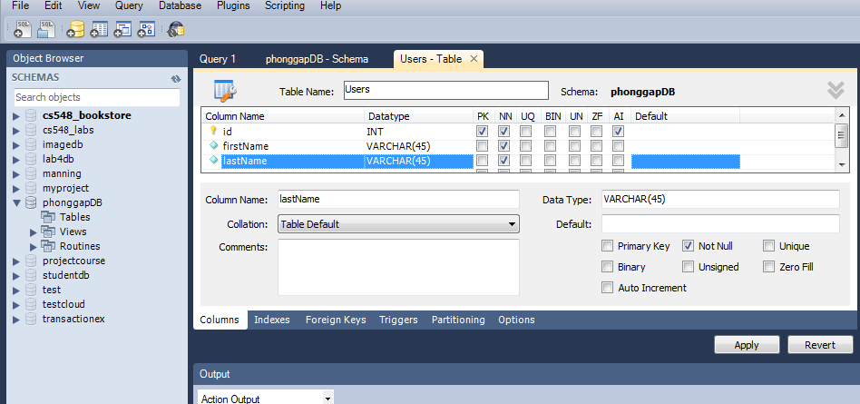

Click Apply

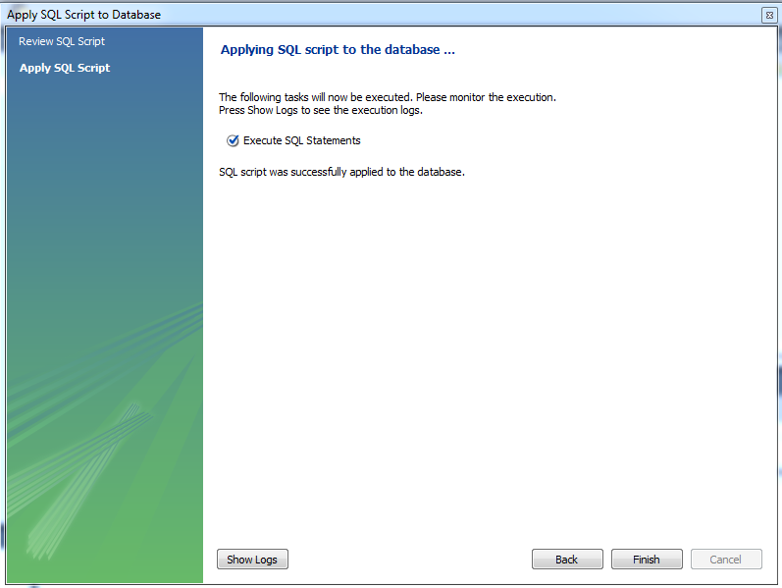

Now we got the following table.

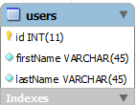

Write some java code to manipulate our database.

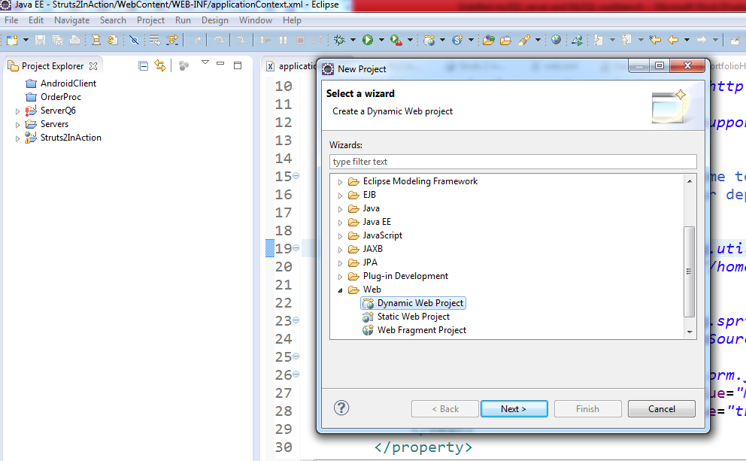

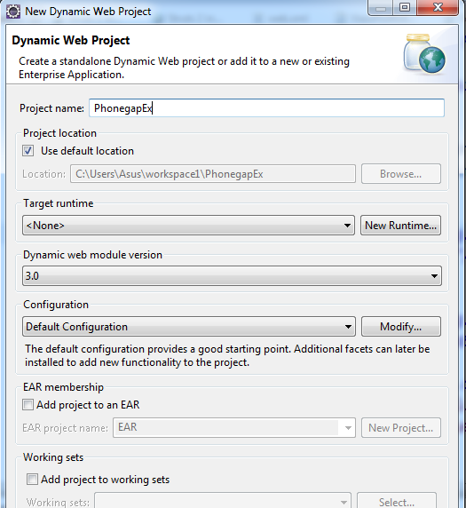

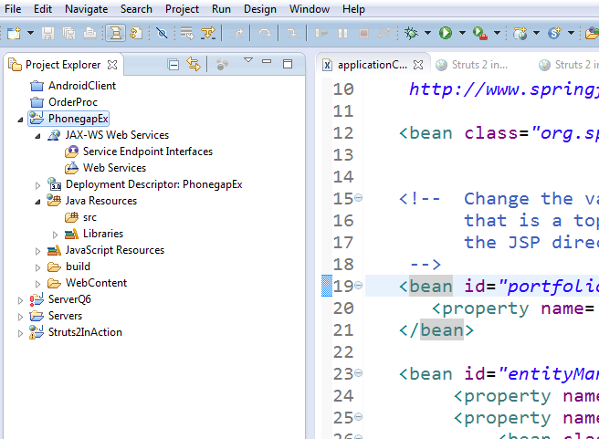

Click on “src” create new class

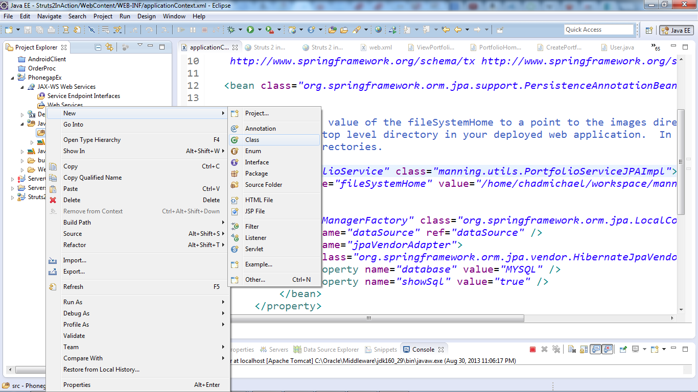

Enter Name class : Users and package” com.xxx.xxx”

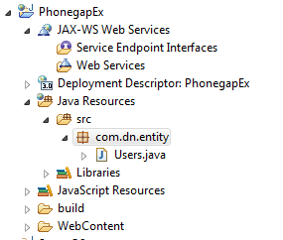

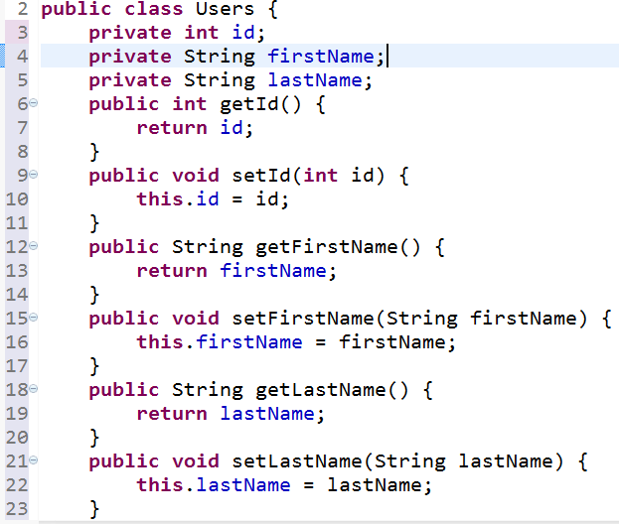

Create Dao (data access object) by using jdbc low level ( this part can be replaced by jdbc template or Hibernate or so on).

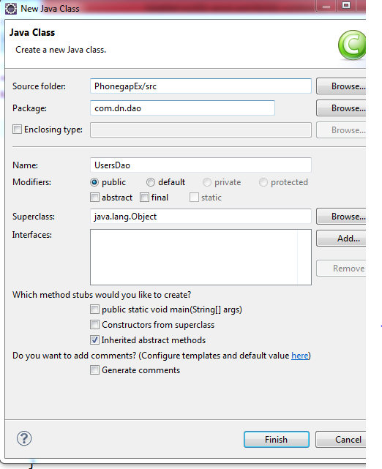

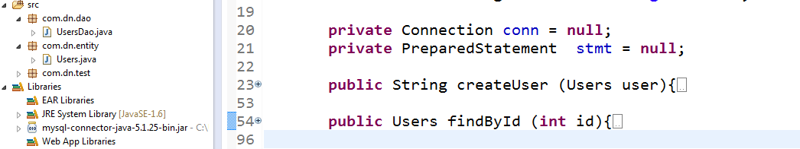

The UsersDao has 2 methods.

createUser: user to create a user to database. Return “yes” if save to database successfully; “no” if fails.

findById: find a user by id.

Source code

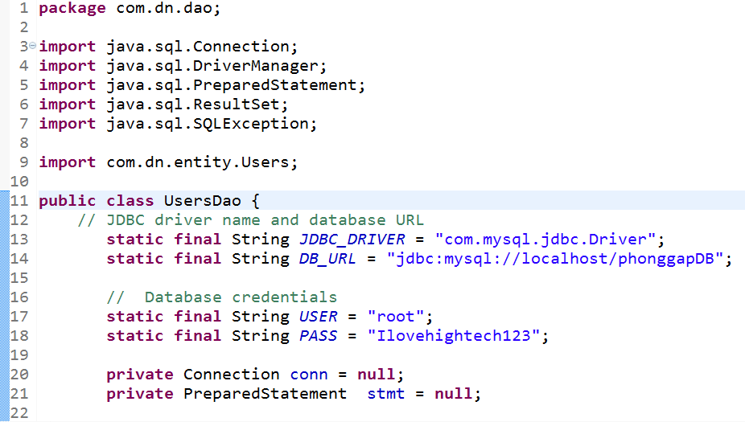

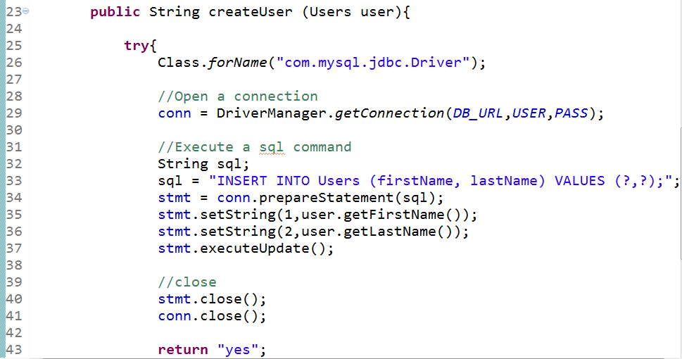

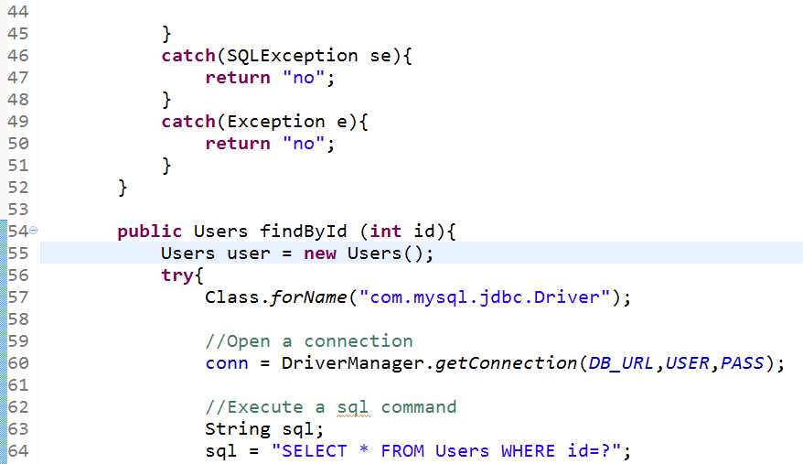

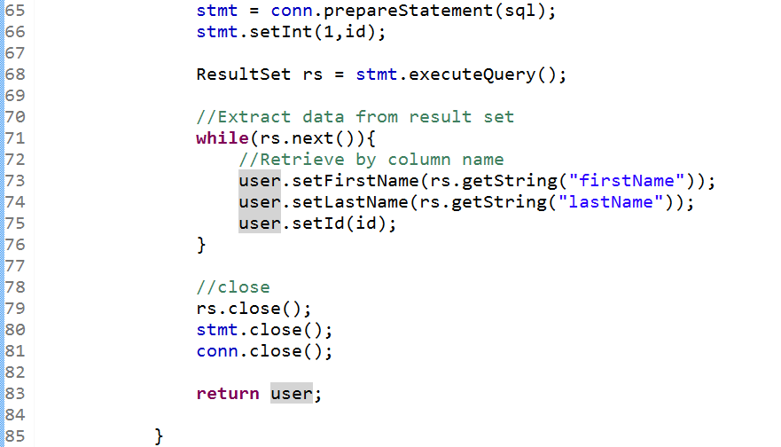

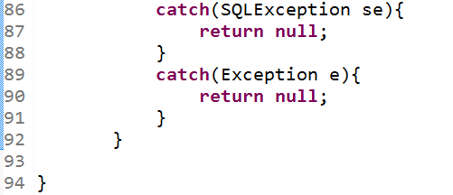

Do a little test with UsersDao class by using simple main method not JUnit.

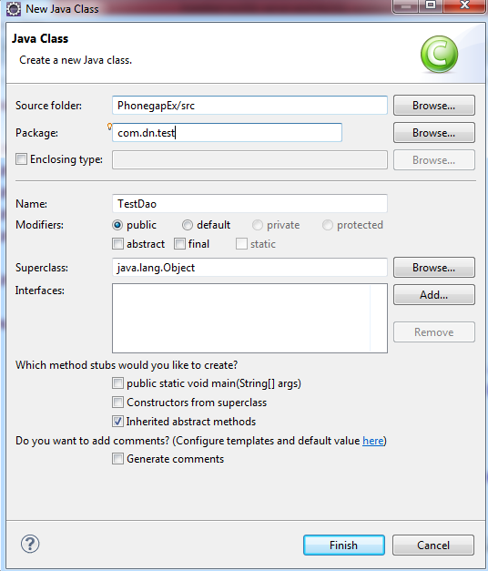

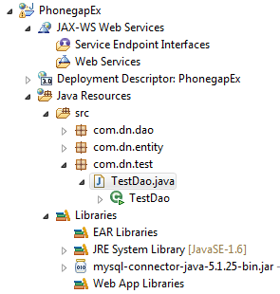

Source code

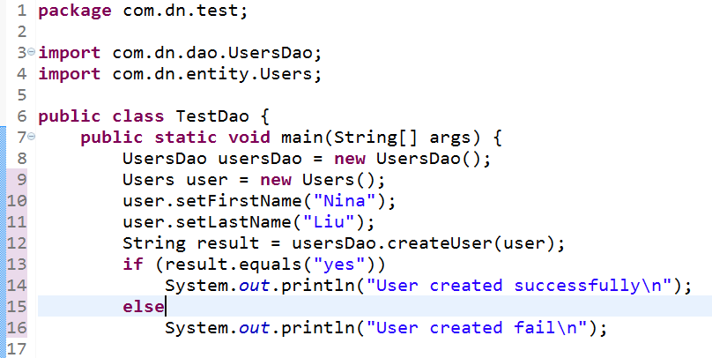

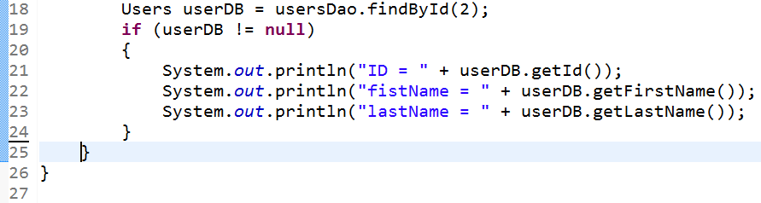

Remember: we need to add mysql-connector-java-xxx to the library

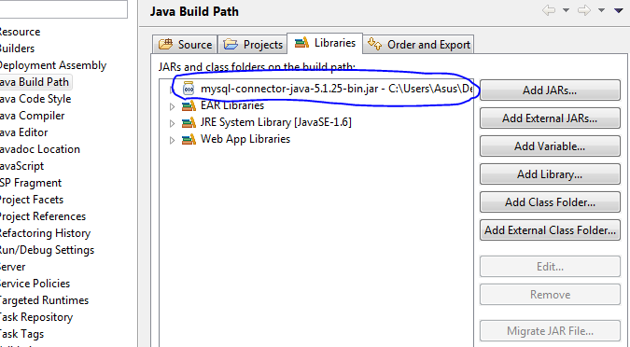

Click on TestDao and run

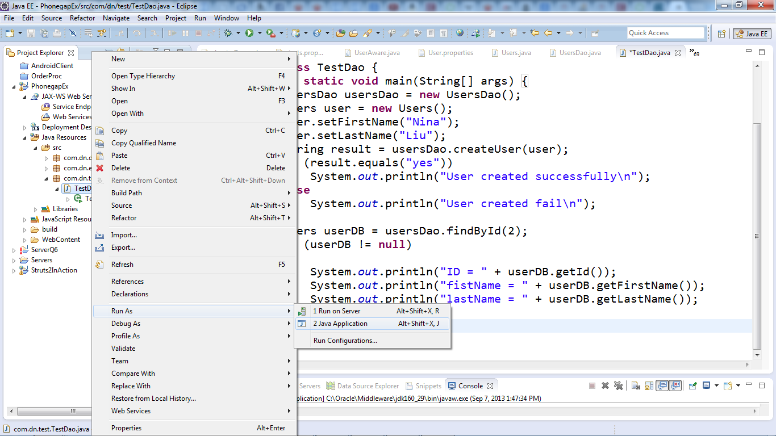

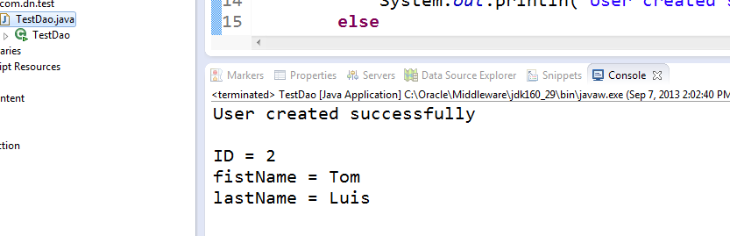

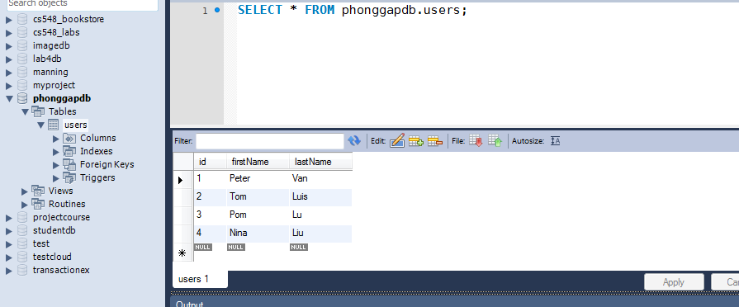

From mysql workbench, we see the user(Nina, Liu) is saved to database and findById(2) gave the right result.

Next create a little Rest web service which wraps around UsersDao.

Right click on project and click Properties.

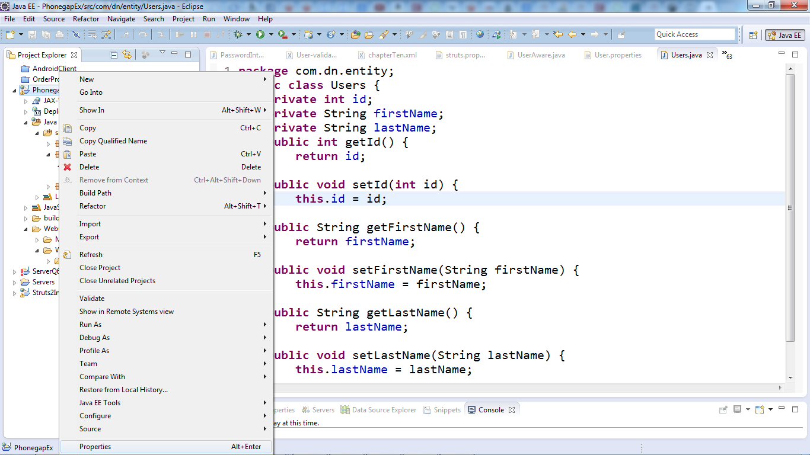

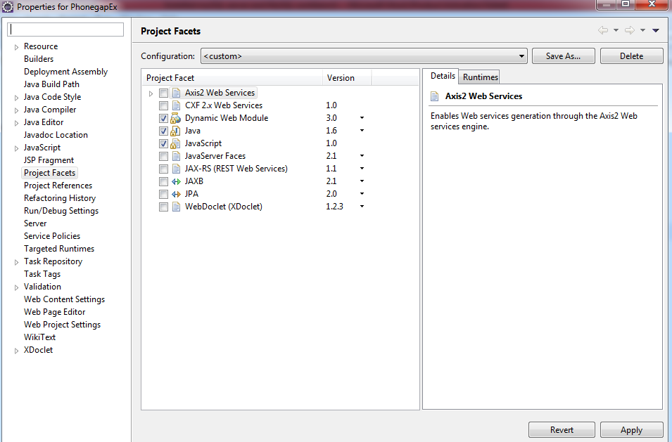

Click on JAX-RS

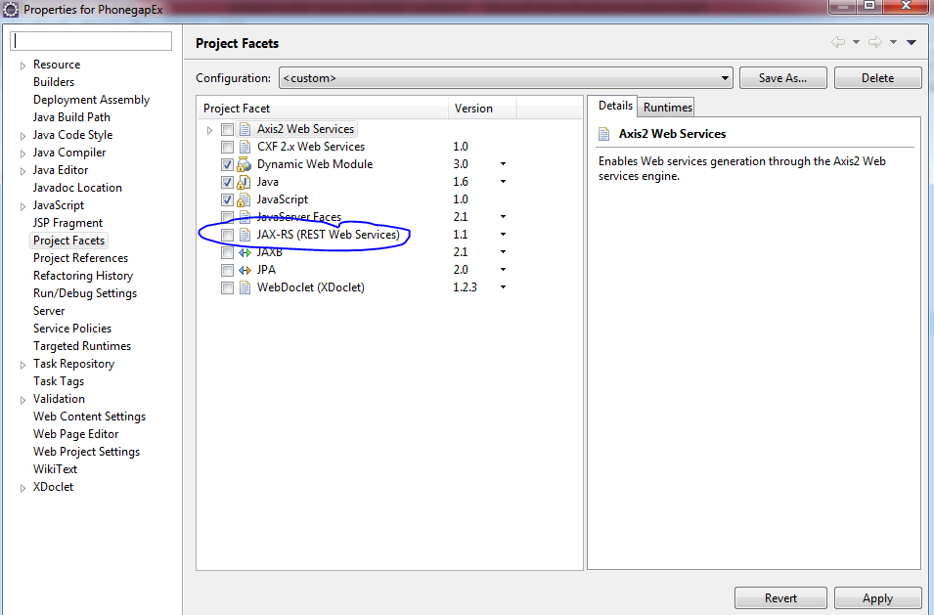

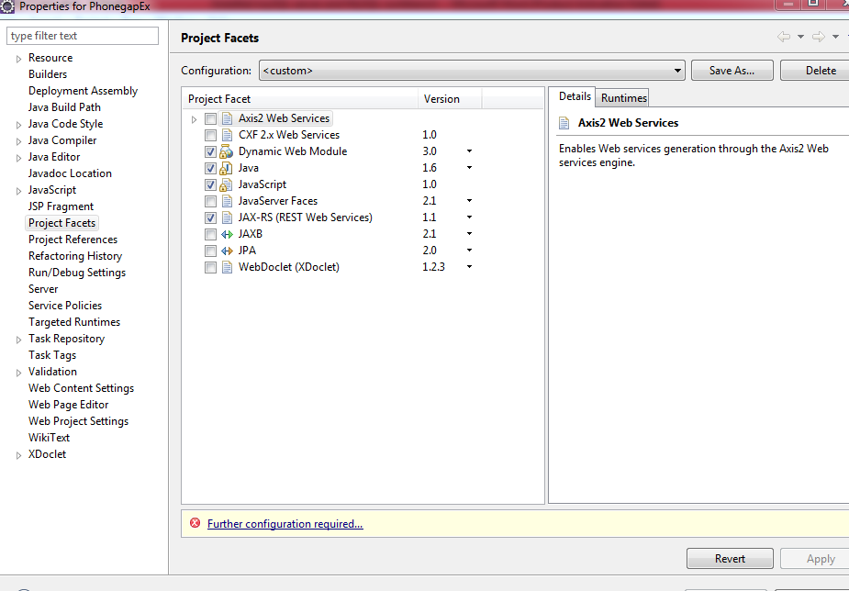

Click on further configuration

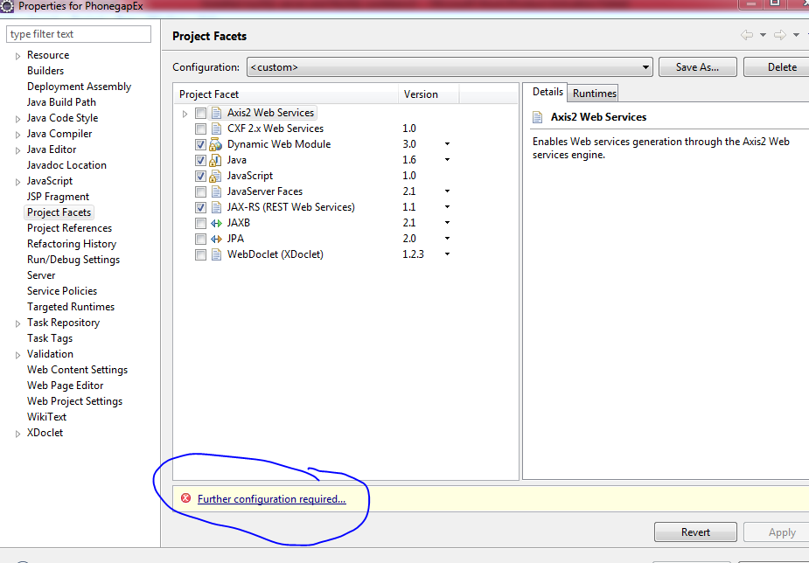

Click on Manage Library

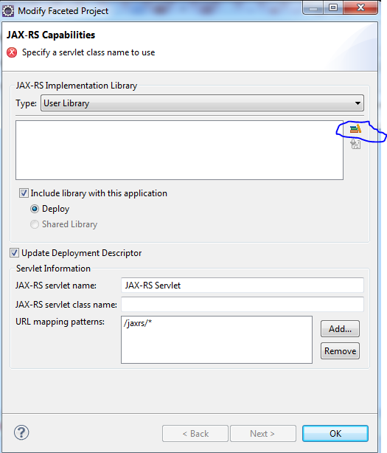

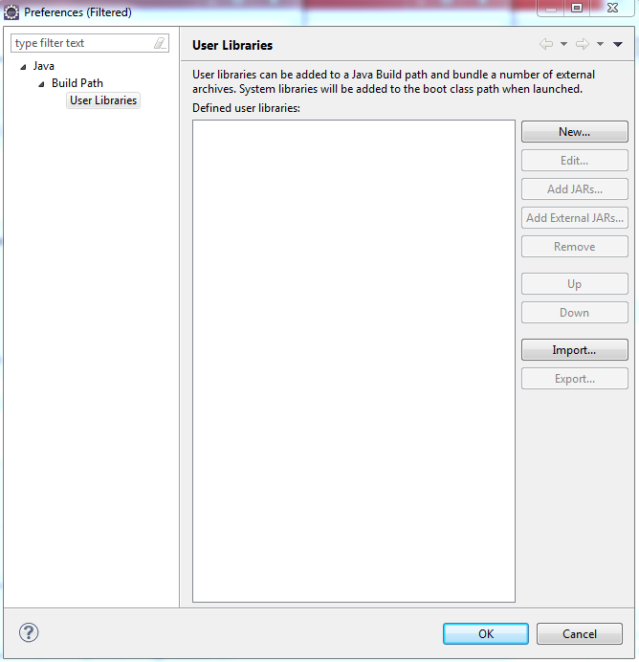

Click New

Give a name, For example RestLib

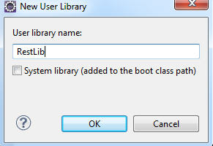

Click Ok.

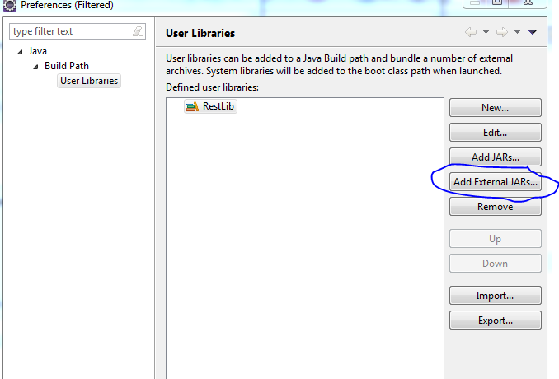

Click on Add external JARs

Add some necessary libraries

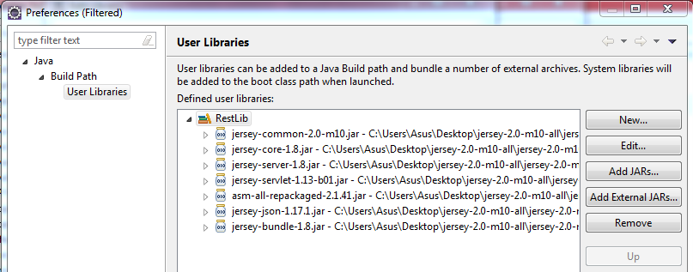

Click Ok

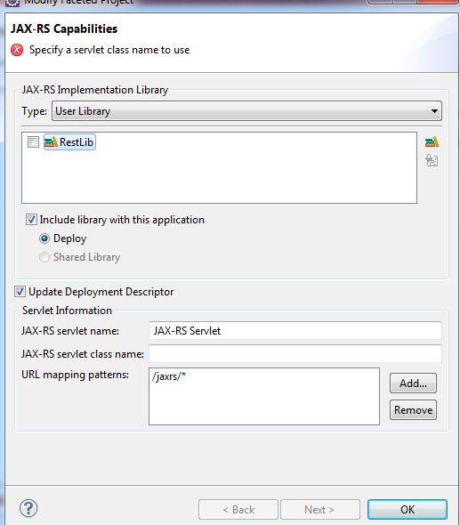

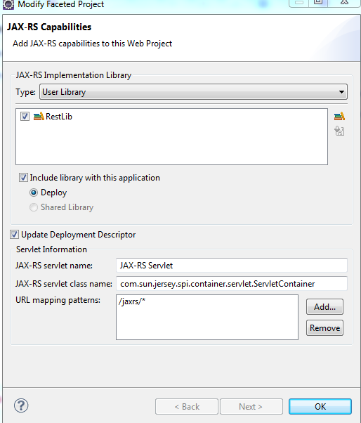

Click Ok

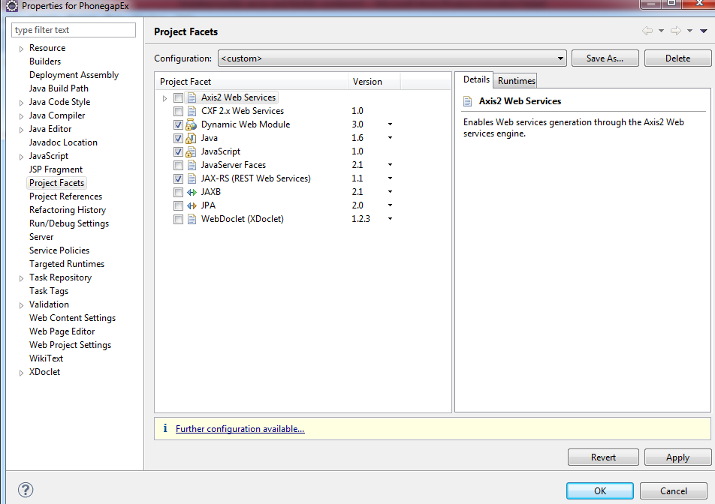

Click Ok. The web.xml is created as following

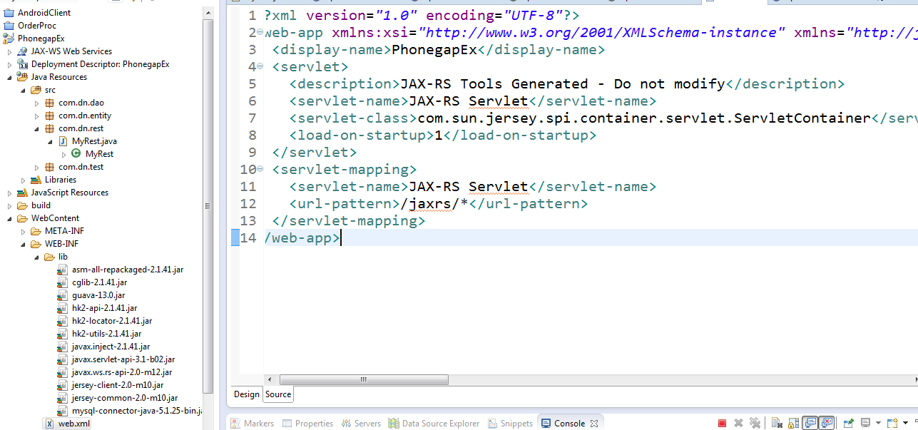

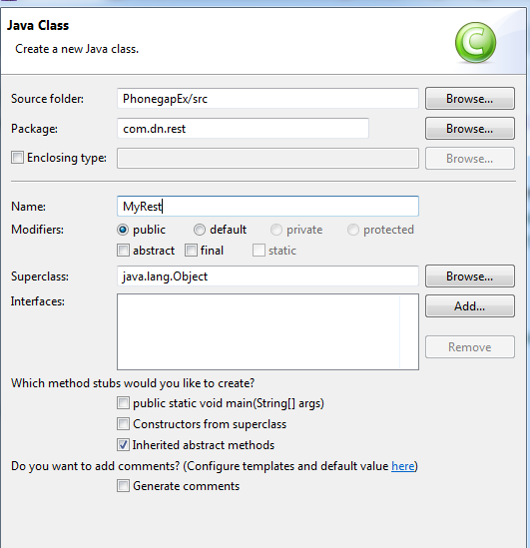

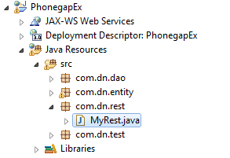

Put the following code to MyRest.java

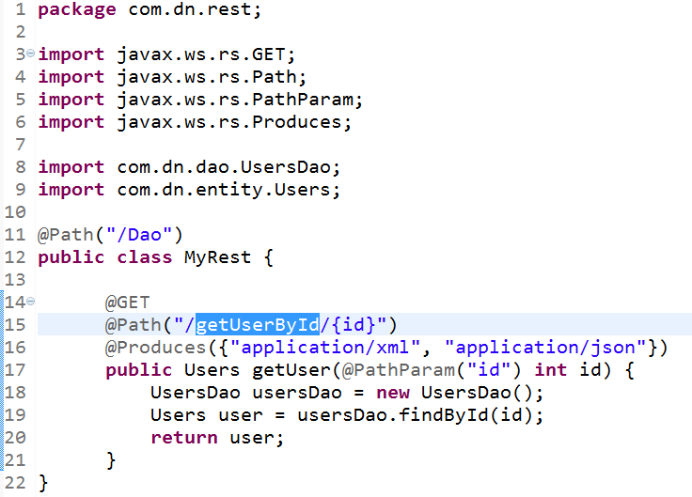

Before run the project on Tomcat server, we need to copy mysql-connector-java-xxx to lib folder as following

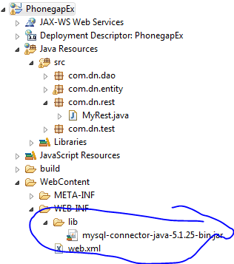

And

Change the code of the Users.java a little bit as following

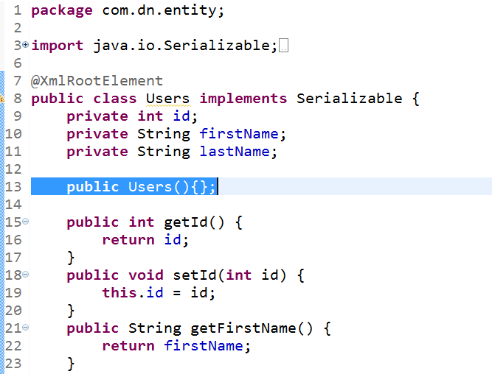

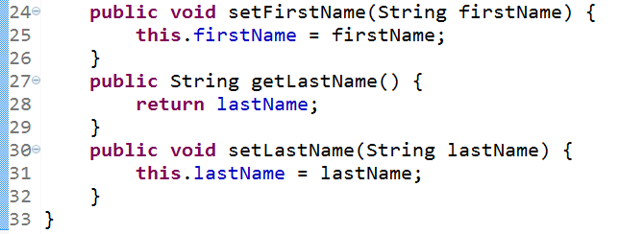

Now run the project on Tomcat server

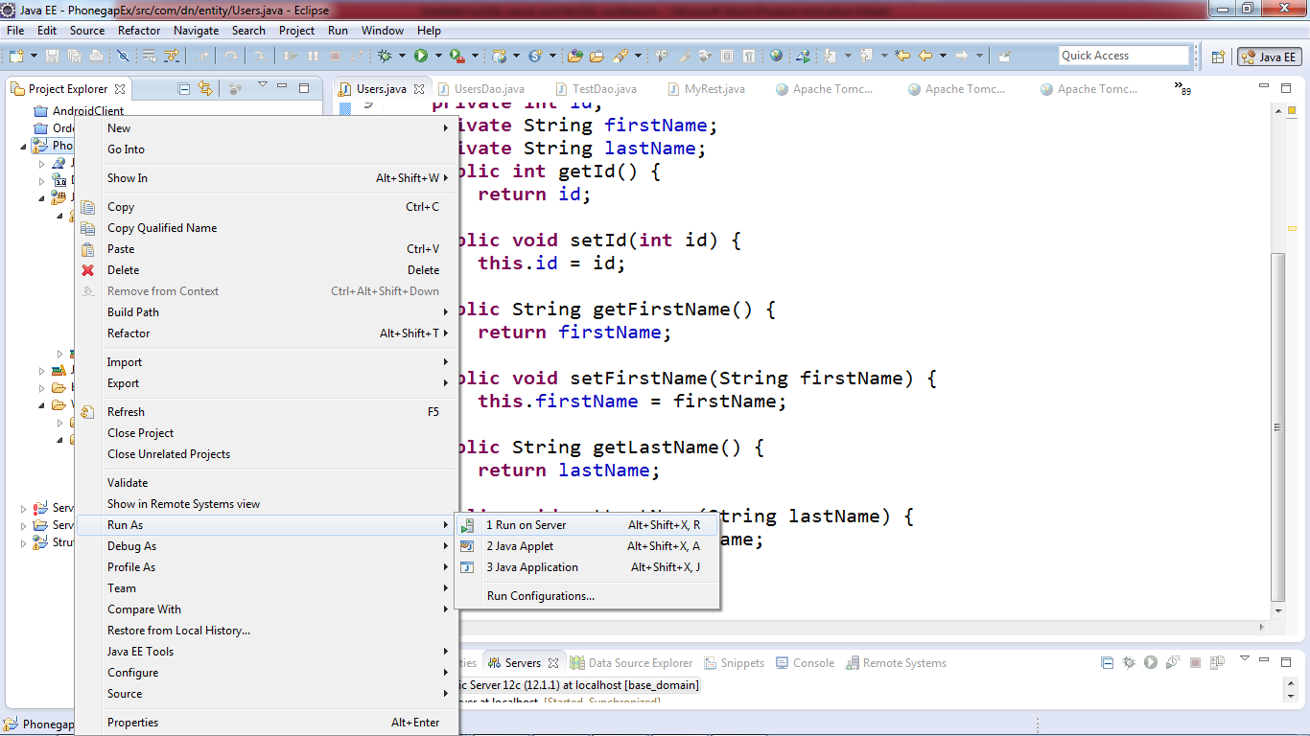

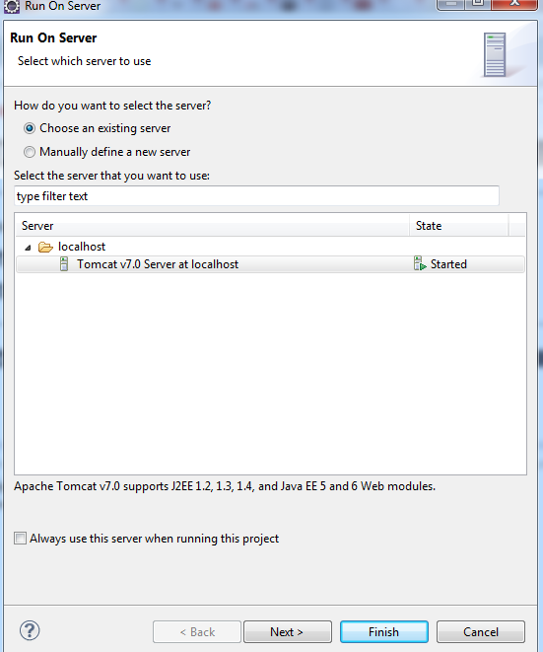

Use the browser to test the result.

Go to the link

<http://localhost:8080/PhonegapEx/jaxrs/Dao/getUserById/2>

* Get the user who has id =2

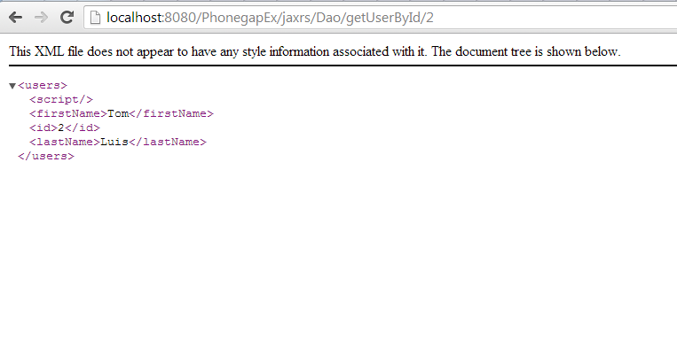

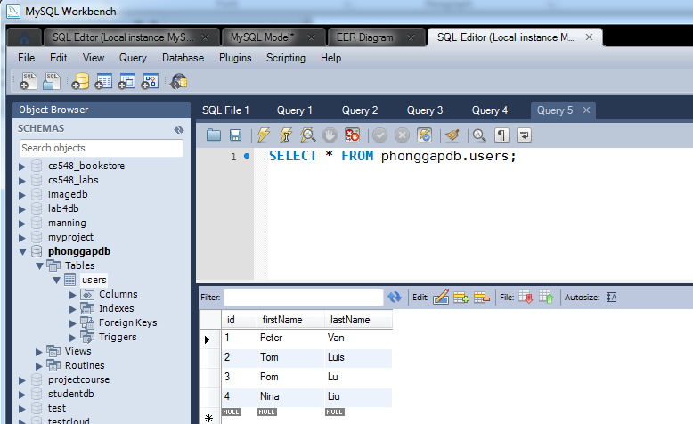

Try again with

<http://localhost:8080/PhonegapEx/jaxrs/Dao/getUserById/4>

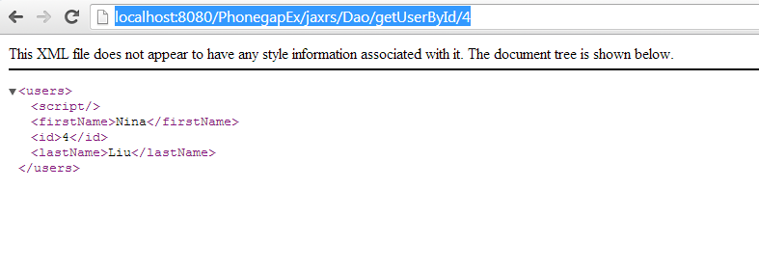

Right now, the MyRest.java has only getUserById. Add more method to MyRest.java as the following.

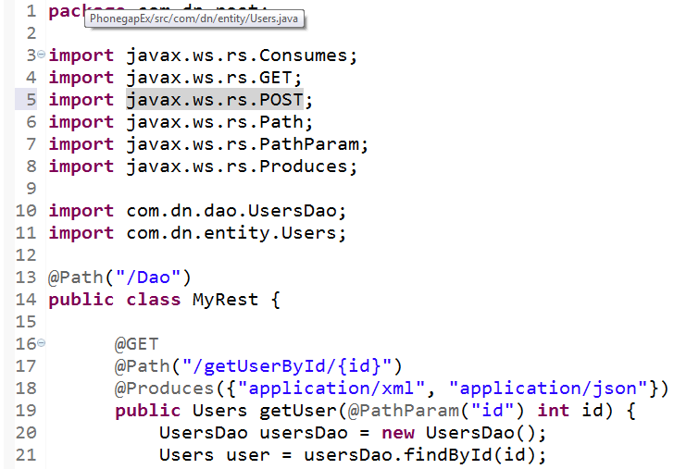

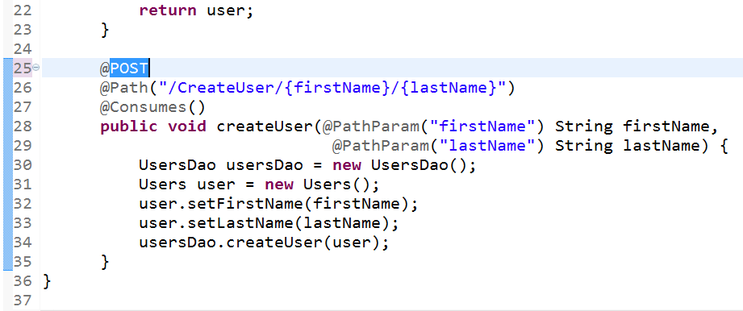

And now we can save a new user to database by using uri with a POST method

<http://localhost:8080/PhonegapEx/jaxrs/Dao/CreateUser/firstName/lastName>

For example, to save a user with first name : Tina, last name: Le 🡪

http:// localhost:8080/PhonegapEx/jaxrs/Dao/CreateUser/Tina/Le + POST method. More detail: next section.

1. **Programming for client side.**

The client side can use the Rest Web service in the above to get information of user from database. For example, access this link <http://localhost:8080/PhonegapEx/jaxrs/Dao/getUserById/4>, we will get

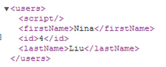 in XML or in Json.

The client can also create a new user and save to database. For example,

In this section, we will use html, jQuery, and Phonegap to build Android application. Even we don’t know much about Android programming.

Open Eclipse ADT-bundle and create a new Android project.

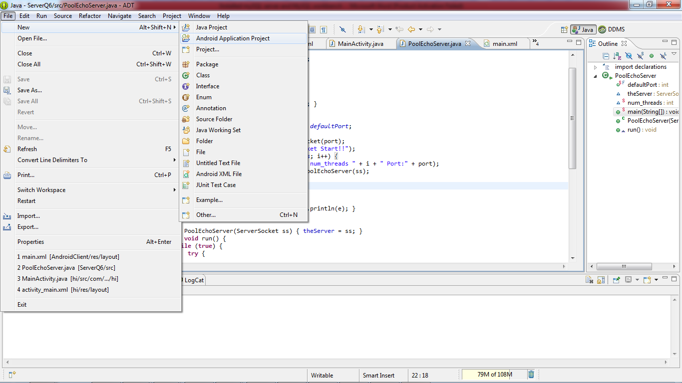

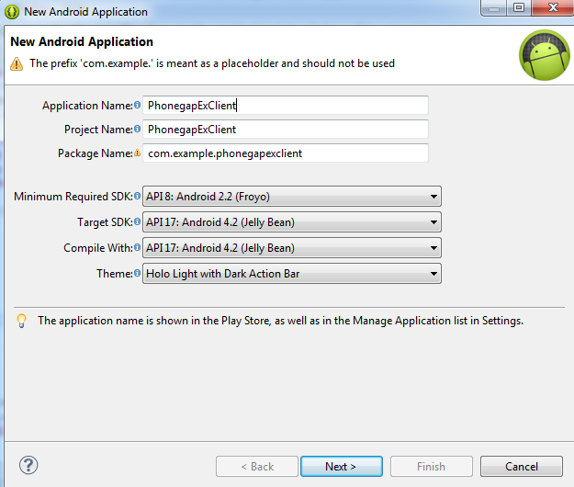

Click next, next..

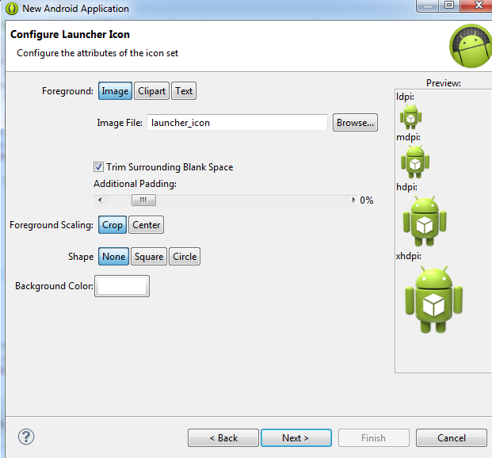

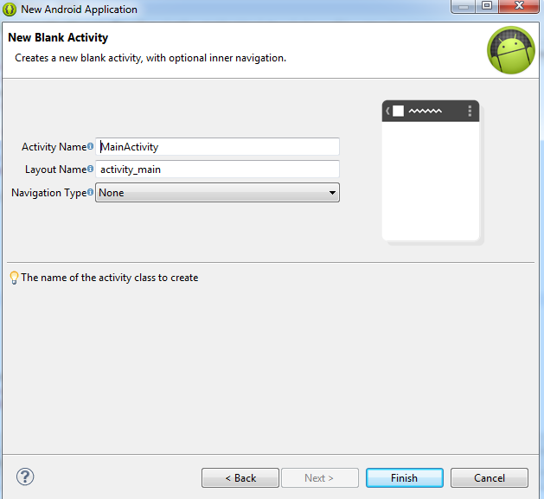

And finish

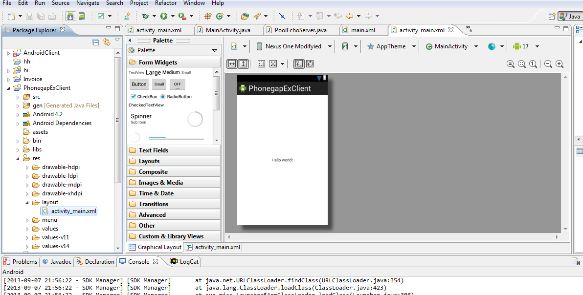

Go to phonegap website and download phonegap package.

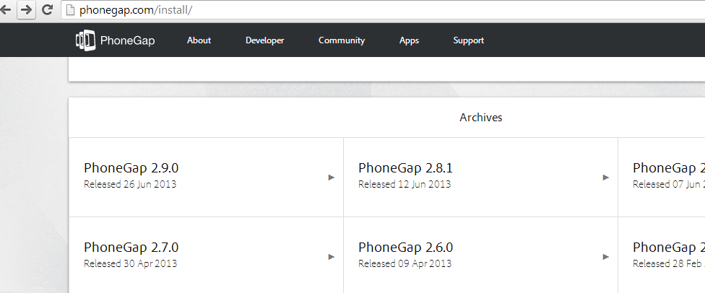

Create a folder www in the assets folder

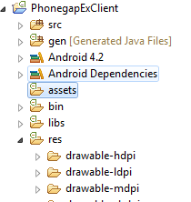

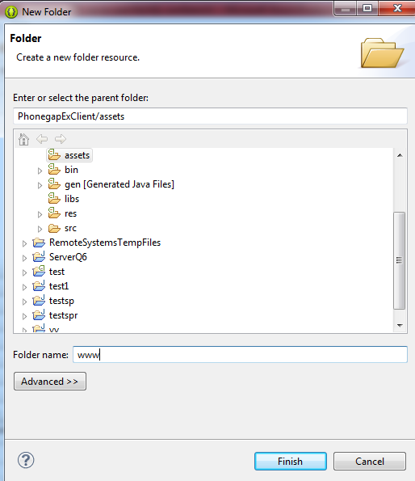

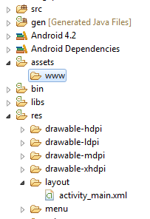

After downloading phonegap, unzip it



Go to lib folder, Android folder

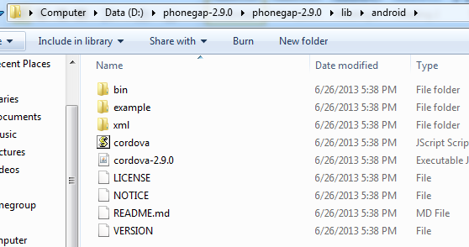

Copy cordova.js to www folder

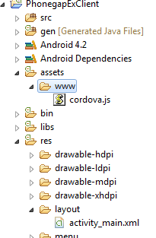

Also copy



To libs folder and add it to classpath

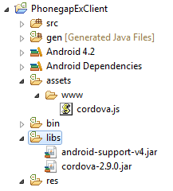

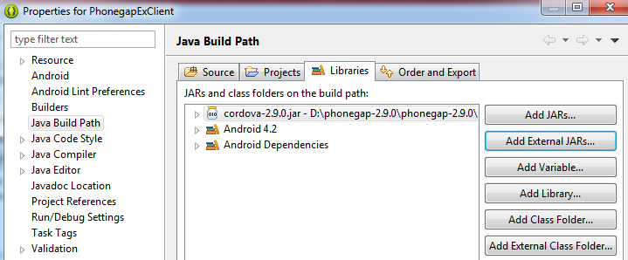

Copy xml folder to res folder

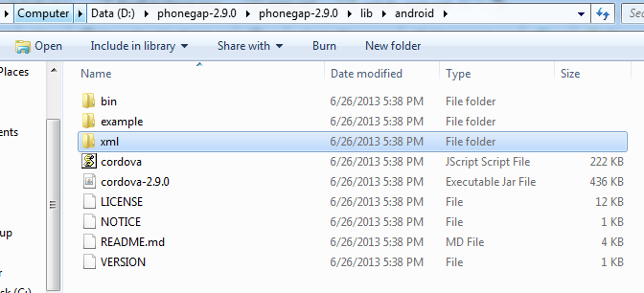

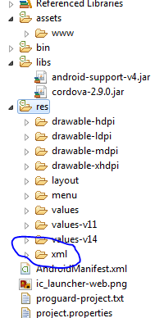

Open AndroidManifest.xml and add some code for screen and permission as following

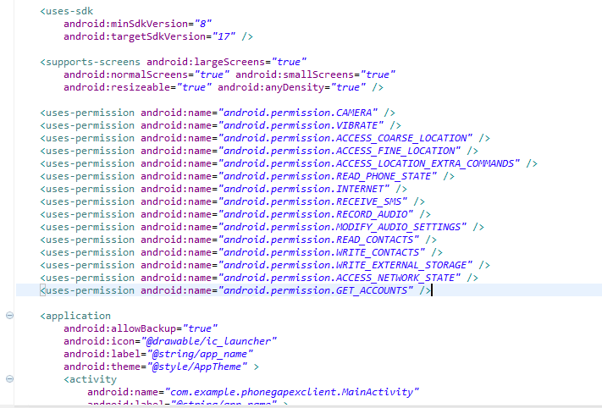

Open MainActivity.java and change the code into

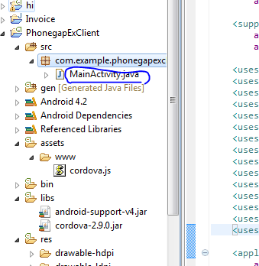

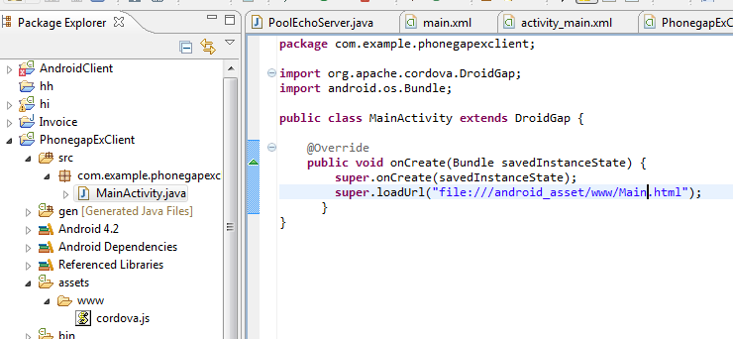

Add Main.html and some js libraries to www folder

Main.html

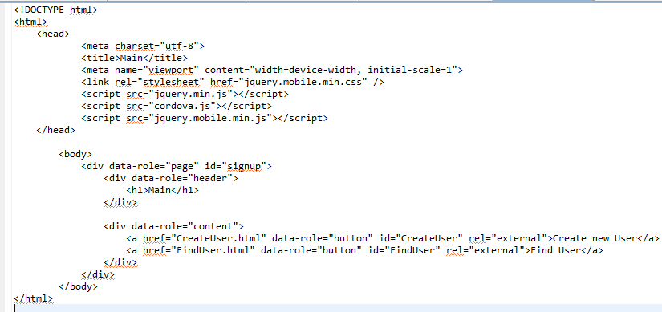

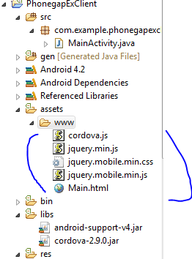

Click Run Android Application

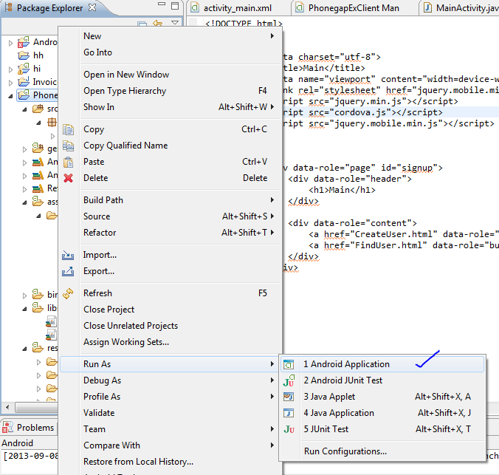

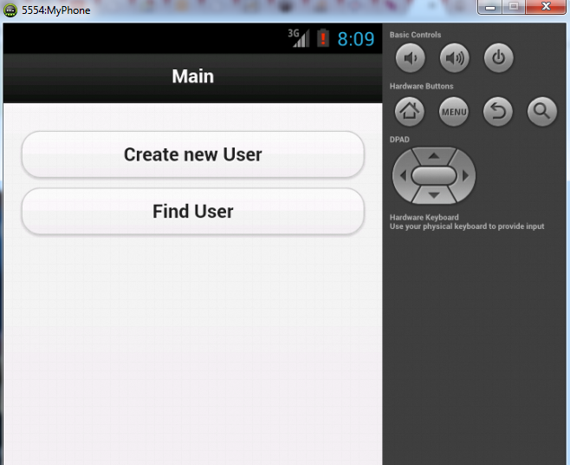

Next we need add 2 files: CreateUser.html and FindUser.html to www folder

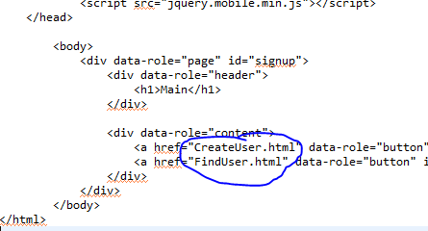

First, doing with FindUser.html

FindUser.html

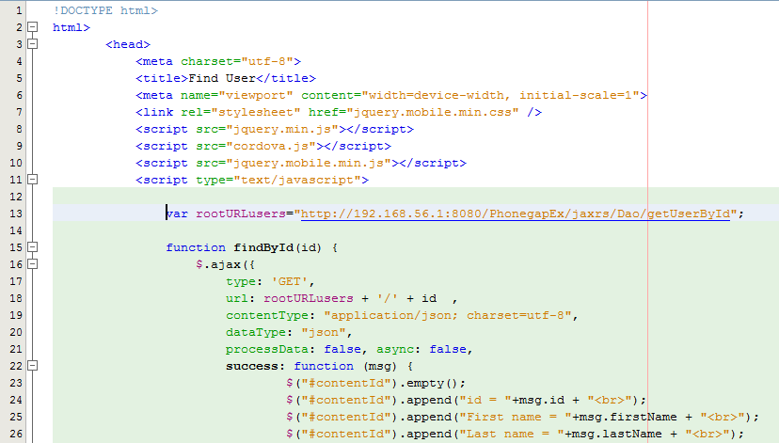

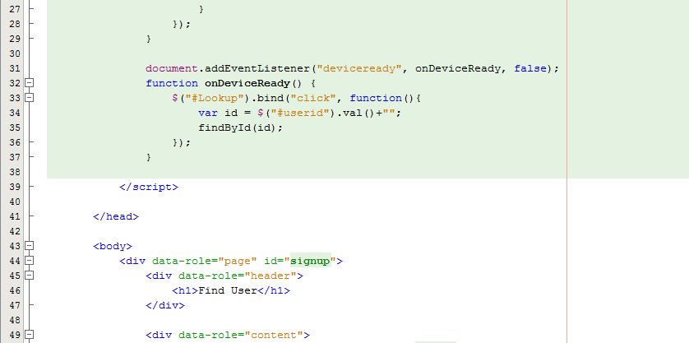

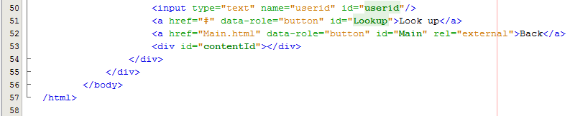

For the link, we cannot use localhost, we need to replace with our host ip

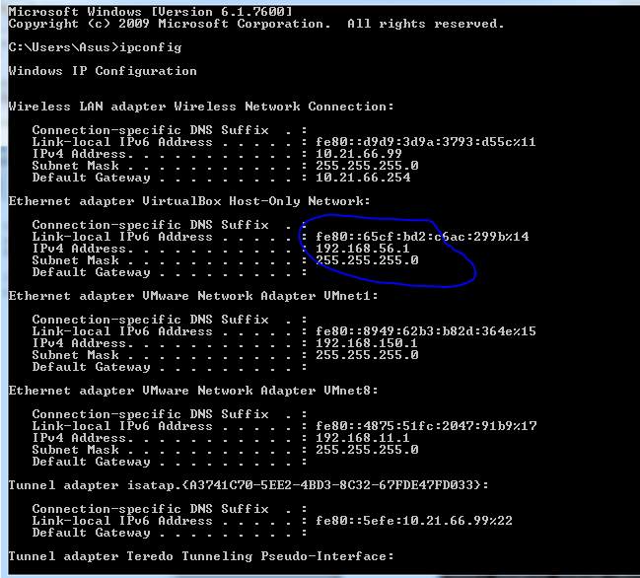

Use 192.168.56.1

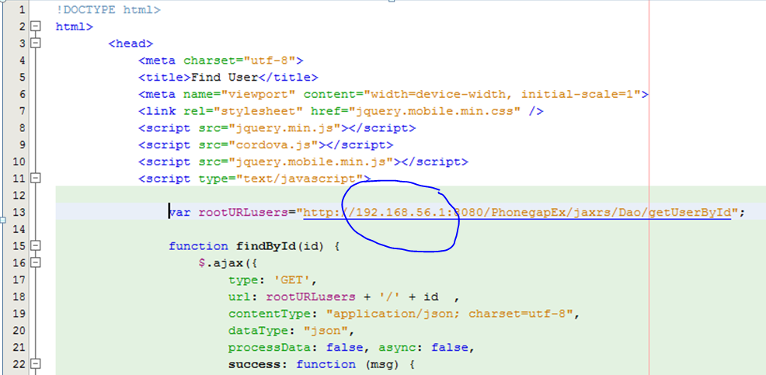

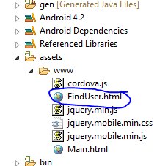

Now run the program

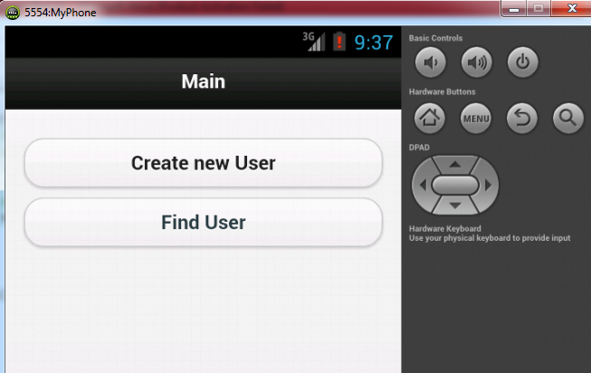

Click on Find User

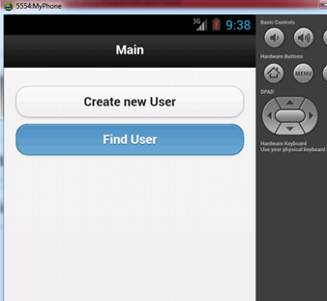

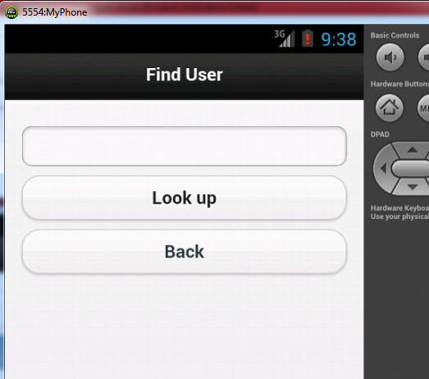

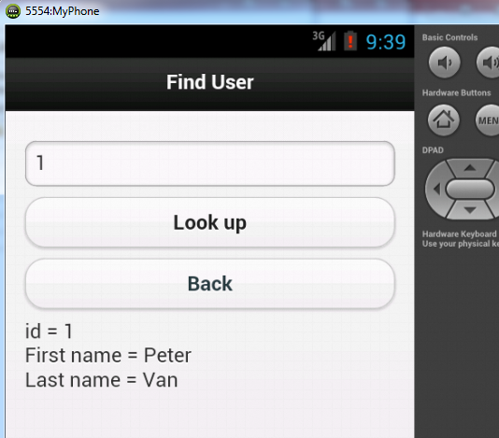

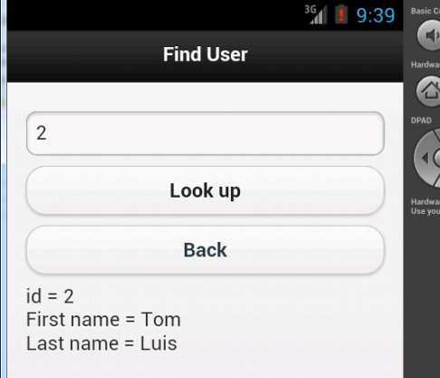

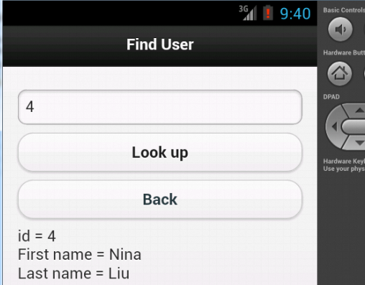

Click Back

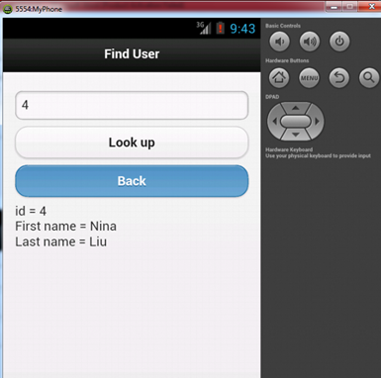

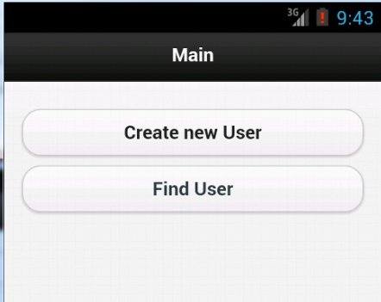

Second, doing with CreateUser.html

CreateUser.html

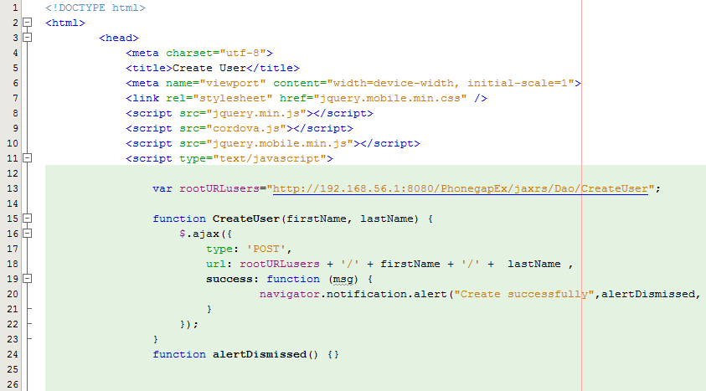

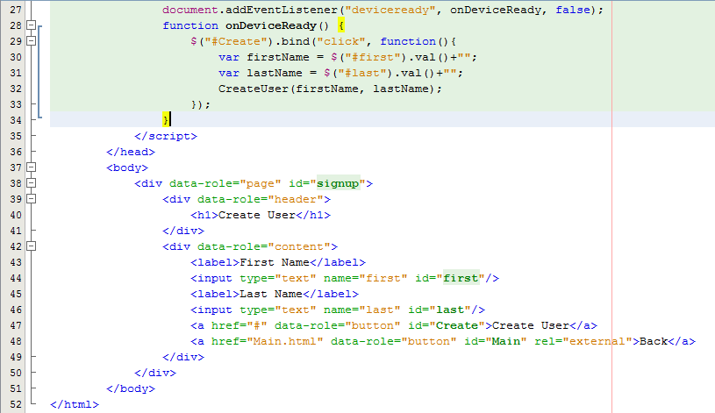

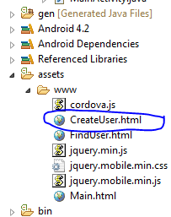

Run the program

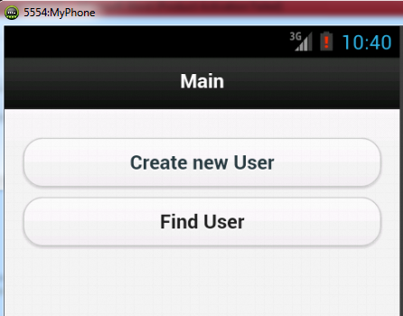

Click Create New User

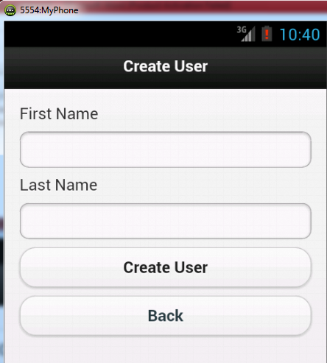

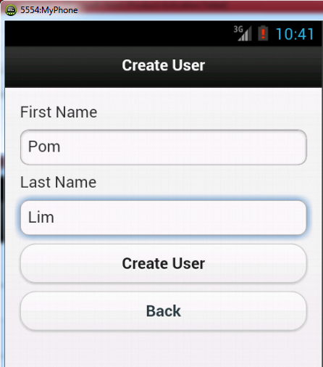

Click Create User

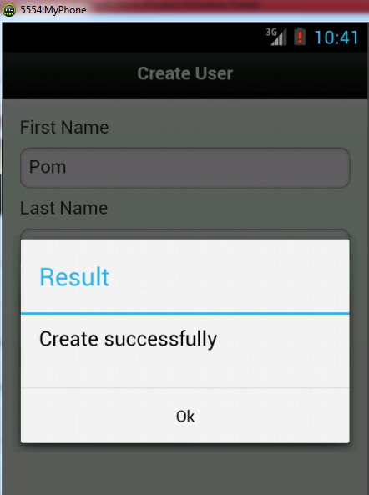

Click Ok

Check database

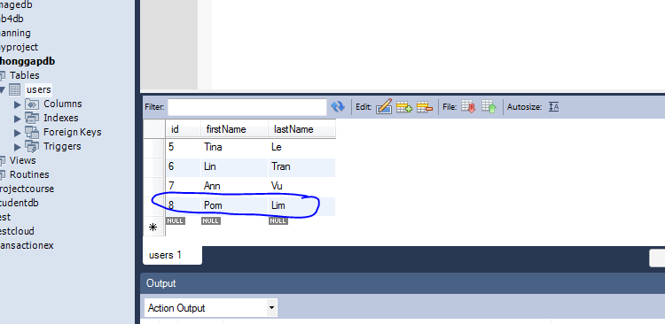

-------------------------------------------------------

The above example can be added extended more such as add more column (image 🡪 allow upload image and retrieve image)

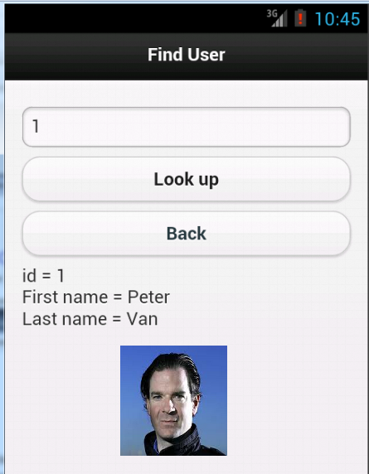

Or save information of users from server to contact database of the phone by using phonegap api : navigator.contacts.create();…..